|  |  |
| --- | --- |
| Course Name | ITD 2313 – Script Programming |
| Instructor | Greg Morris |
| Student Name | Chasity Lusk |
| Due date | 09/07/2025 |
| Grade | Put grade earned here |
| Grading Comments | Put instructor comments here |

Python Language

Install Python

(If you are using the Azure VM you will just need to have a screenshot of the program running.)

http://www.python.org

1. Go to the Python Org page (at the website above) and screen shot the home page of the website.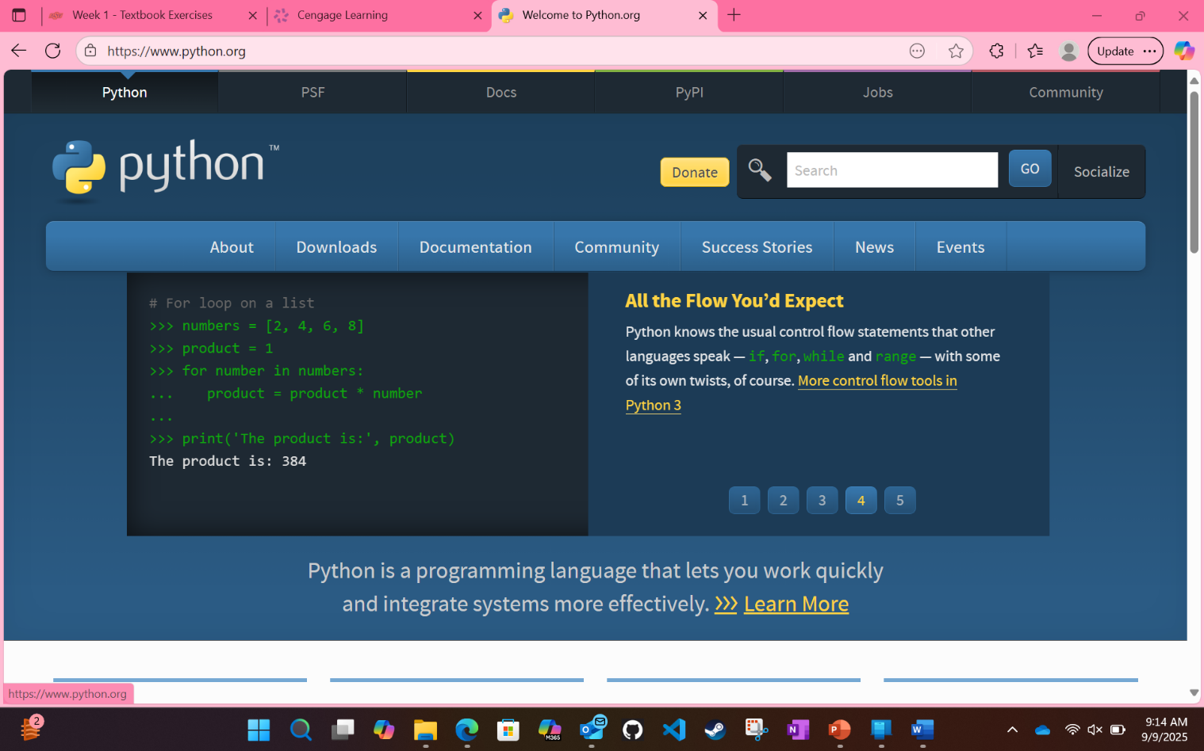
2. Click on the Downloads tab on the home page and then grab a screen shot of the download page.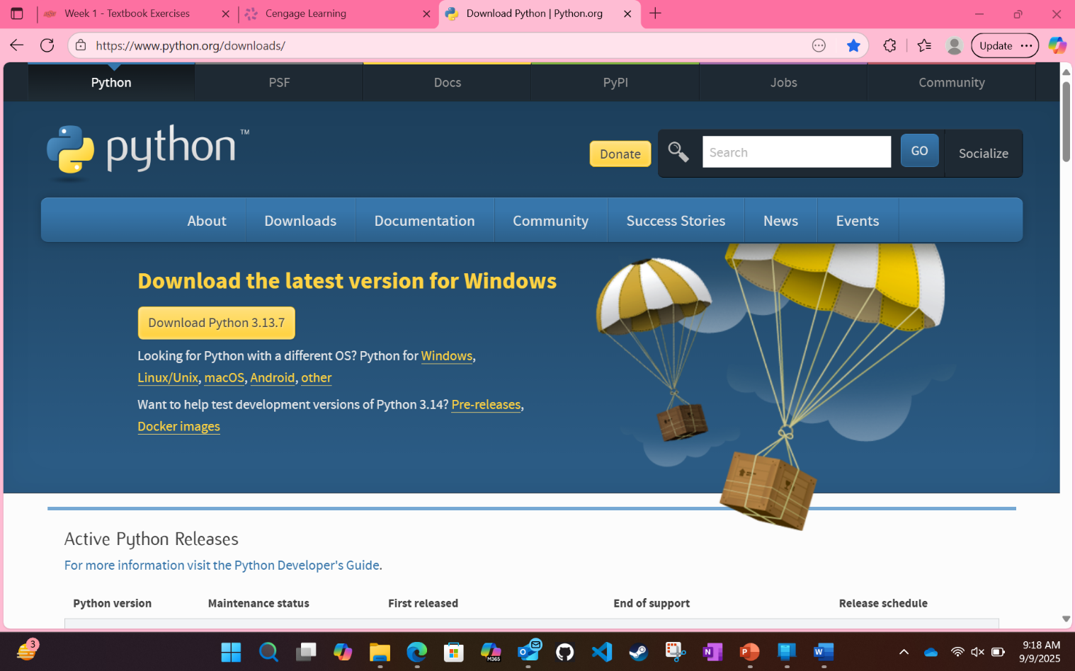
3. Download the most current version for your chosen OS and screen shot the download in progress bar. 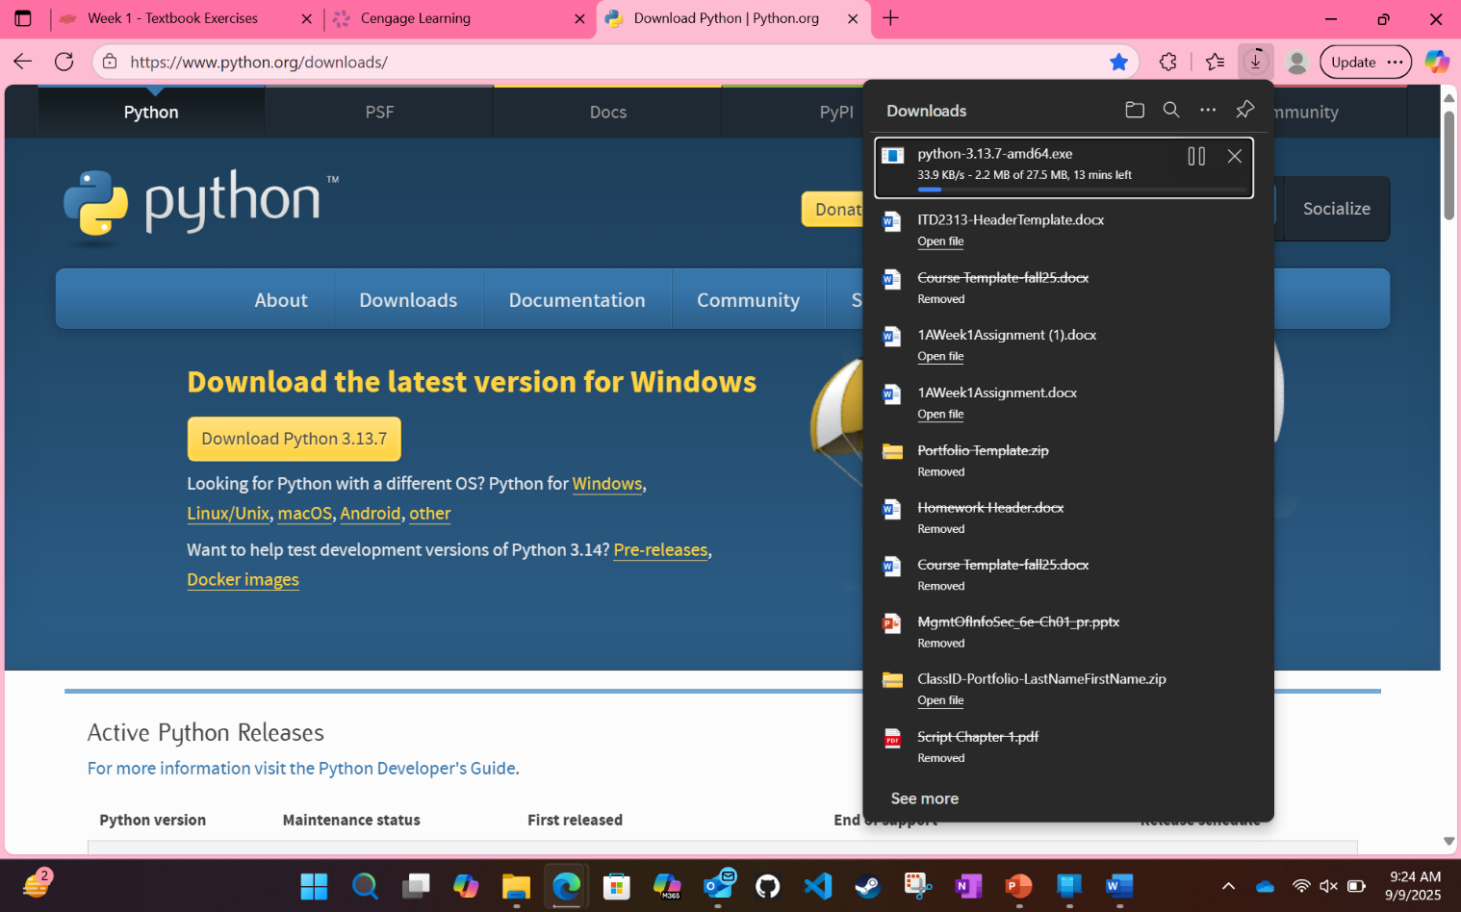
4. Once downloaded, go to your system and install Python and screen shot the installation process at some point showing that Python is installing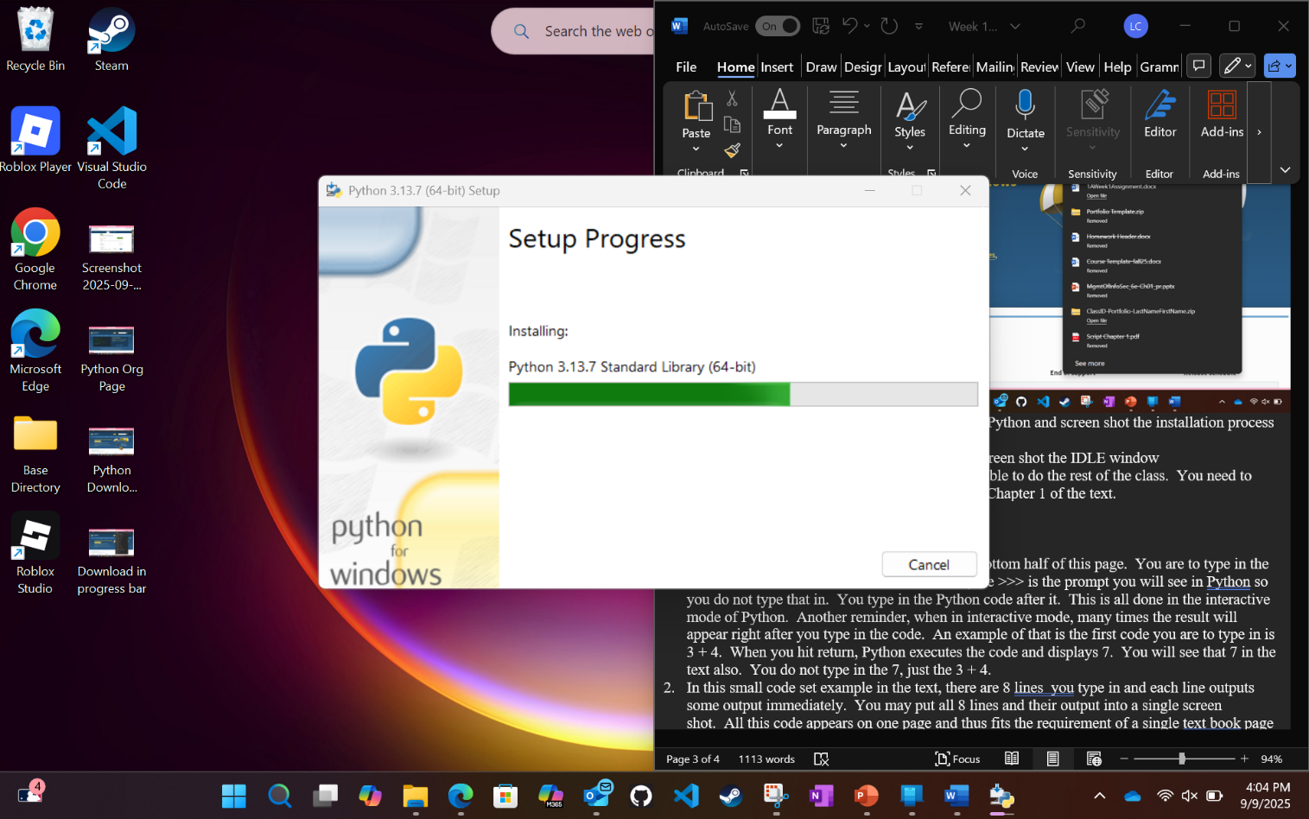
5. Finally, once it is installed, start  up IDLE and screen shot the IDLE window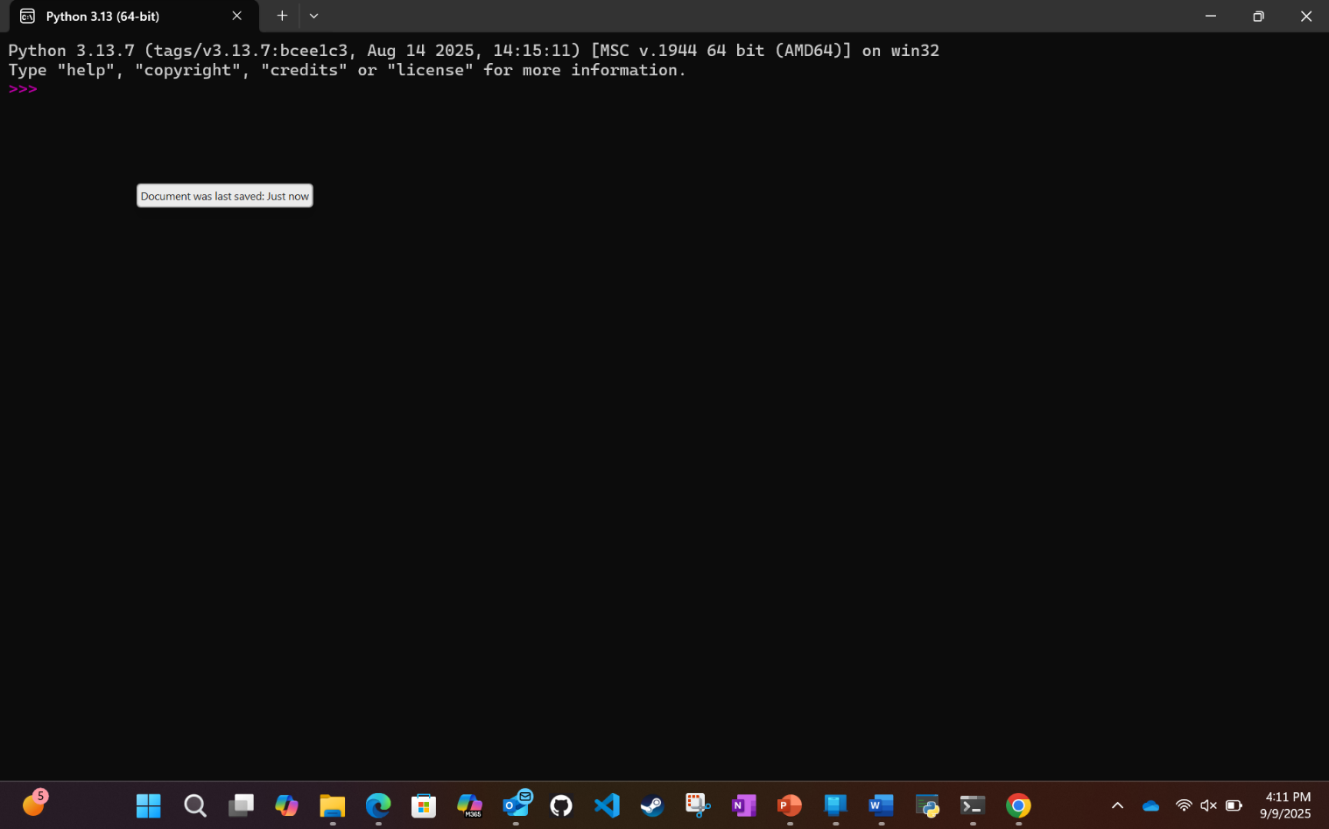

That first task is not in the text but has to be done to be able to do the rest of the class.  You need to have Python installed.  The following tasks are all from Chapter 1 of the text.

Getting Started with Python Programming

Running Code in the Interactive Shell

Page - 17

1. There are several lines of example code on the bottom half of this page.  You are to type in the code as it is seen in the text.  A reminder here, the >>> is the prompt you will see in Python so you do not type that in.  You type in the Python code after it.  This is all done in the interactive mode of Python.  Another reminder, when in interactive mode, many times the result will appear right after you type in the code.  An example of that is the first code you are to type in is 3 + 4.  When you hit return, Python executes the code and displays 7.  You will see that 7 in the text also.  You do not type in the 7, just the 3 + 4.
2. In this small code set example in the text, there are 8 lines  you type in and each line outputs some output immediately.  You may put all 8 lines and their output into a single screen shot.  All this code appears on one page and thus fits the requirement of a single text book page of work.   If you need to use more than a single screen shot, that is okay also.   The important criteria is that you show the 8 lines of code and their respective output.  One more item of note, be sure to read the next numbered bullet point.
3. One of the code lines is name = "Ken Lambert".  You are to use your name between the quotes, not Ken Lambert.  For example, if  your name is John Doe then your code would look like name = "John Doe"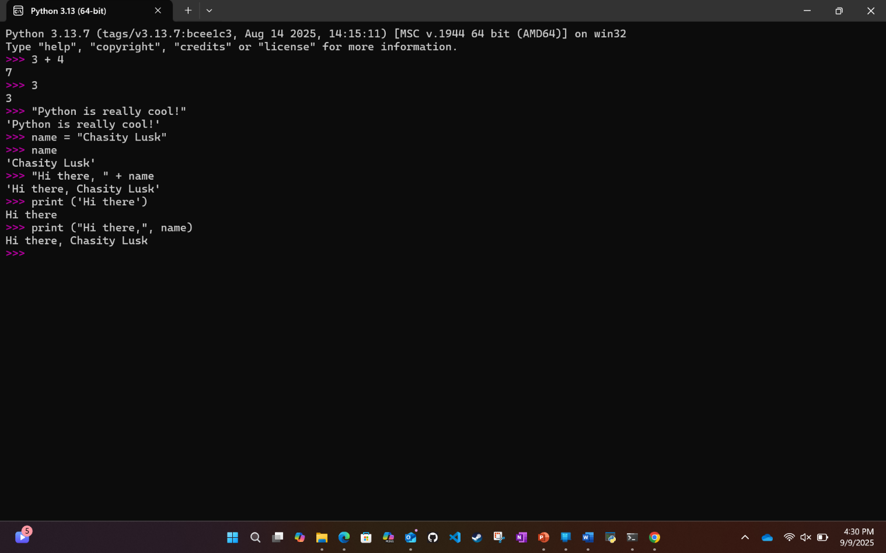

Input, Processing, Output

Page 18

1. At the top of the page, there is a single line of code to type in an example
2. At the bottom of the page, there are a few lines that need to be typed in for the example.  As with the previous instructions, replace Ken Lambert with your name.
3. Screen shot the first two steps.  As they are on the same text page,  you may use a single screen shot to grab both of them.

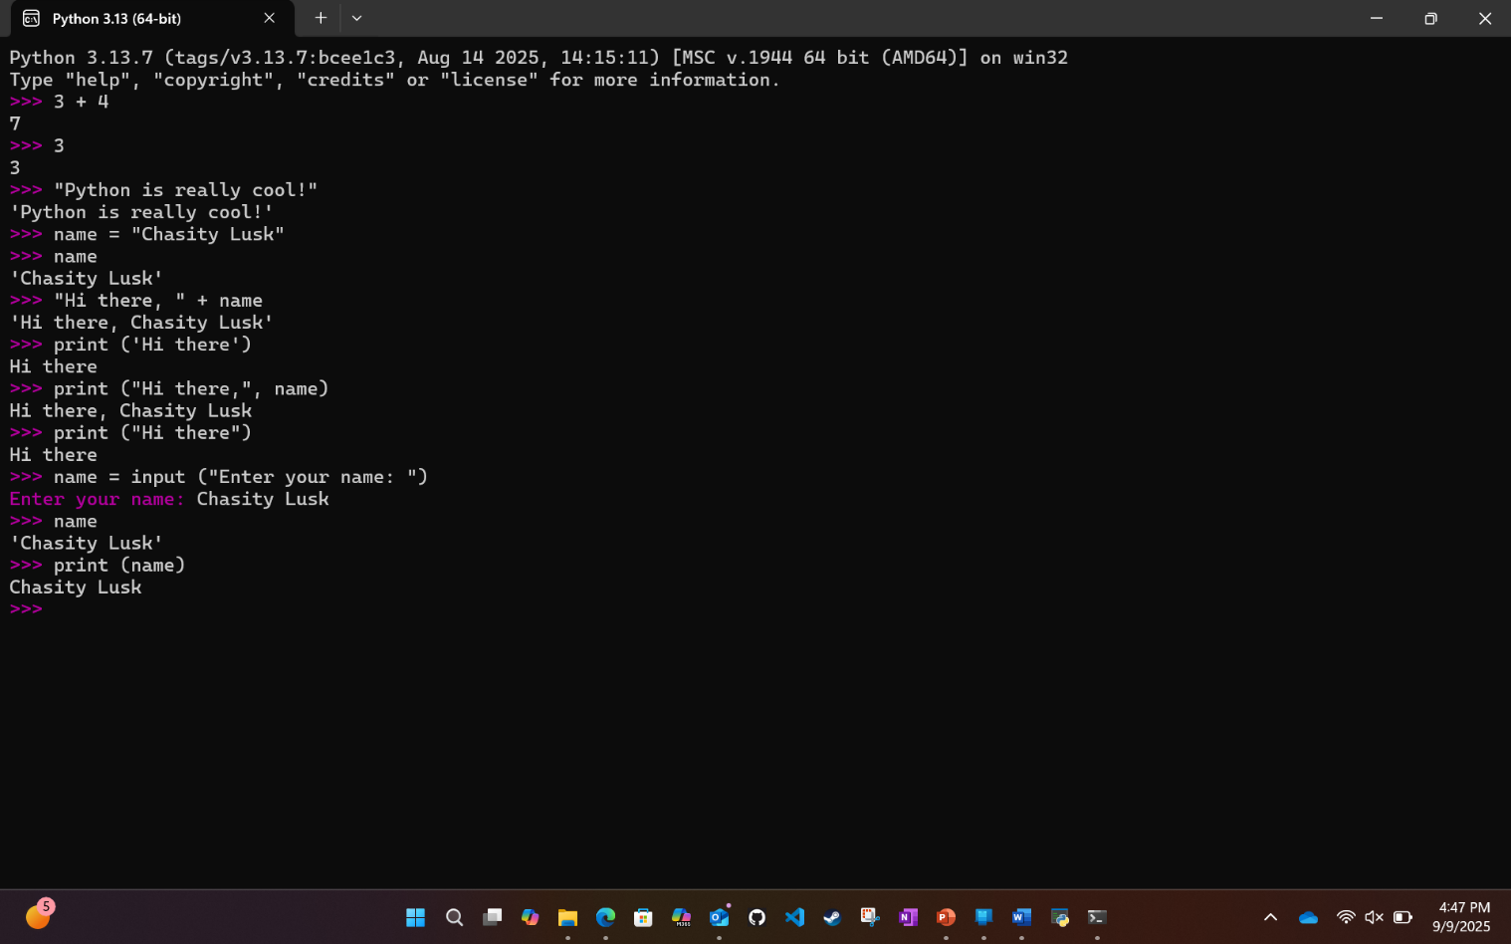

Page 19

1. About 1/3 the way down the page is a single example code line to type in.  While you will type in the variable as shown, your results show display your name instead of Ken Lambert because you changed that information up on page 25 when you created it.
2. Just a small bit lower on the page, there are 3 lines of code to input and see the results.  Use the numbers they show in their example so that you can see that is works as it is suppose to.  You can go back later after grabbing your screen shot and do it again if you want with different numbers.
3. Screen shot the first two steps.  As they are on the same text page,  you may use a single screen shot to grab both of them.

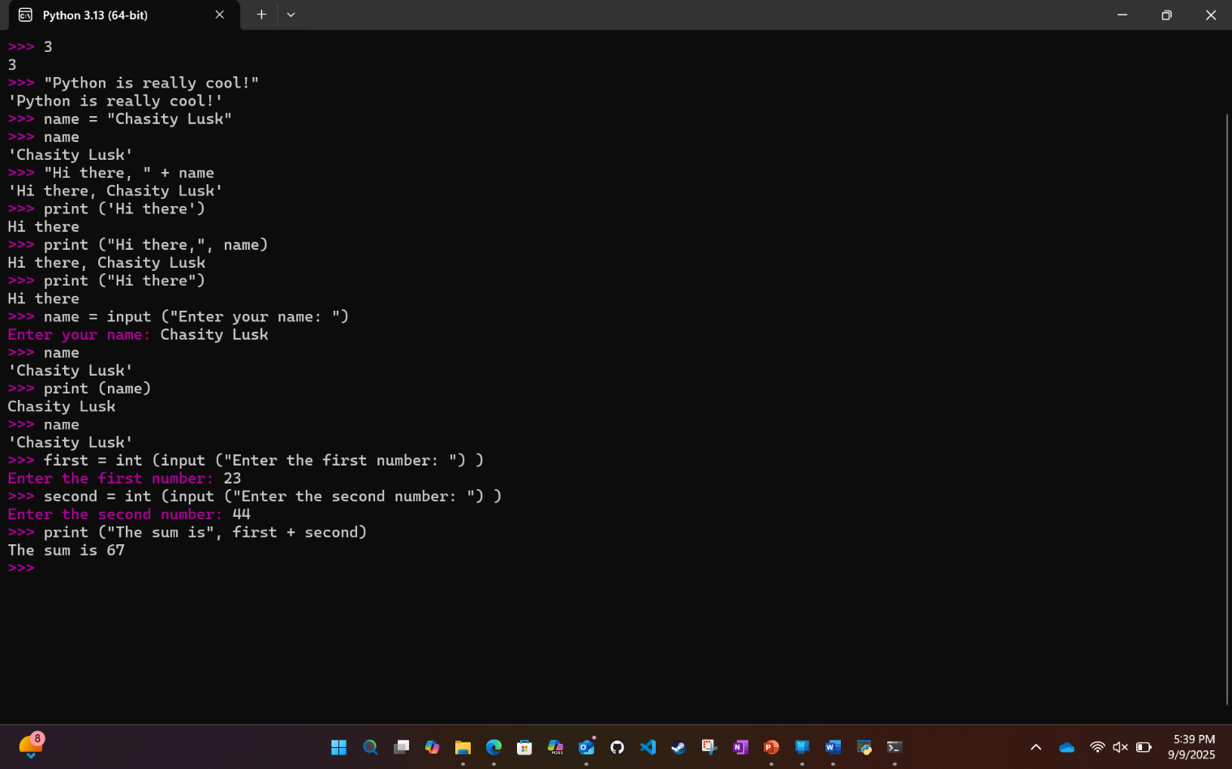

Editing, Saving, and Running a Script

Page 20

1. Using the IDLE type in the code from figure 1-7 and run the program.  Make sure that you get a screenshot of the code and the program running.  Use the numbers listed in the book as well as (35, 43)

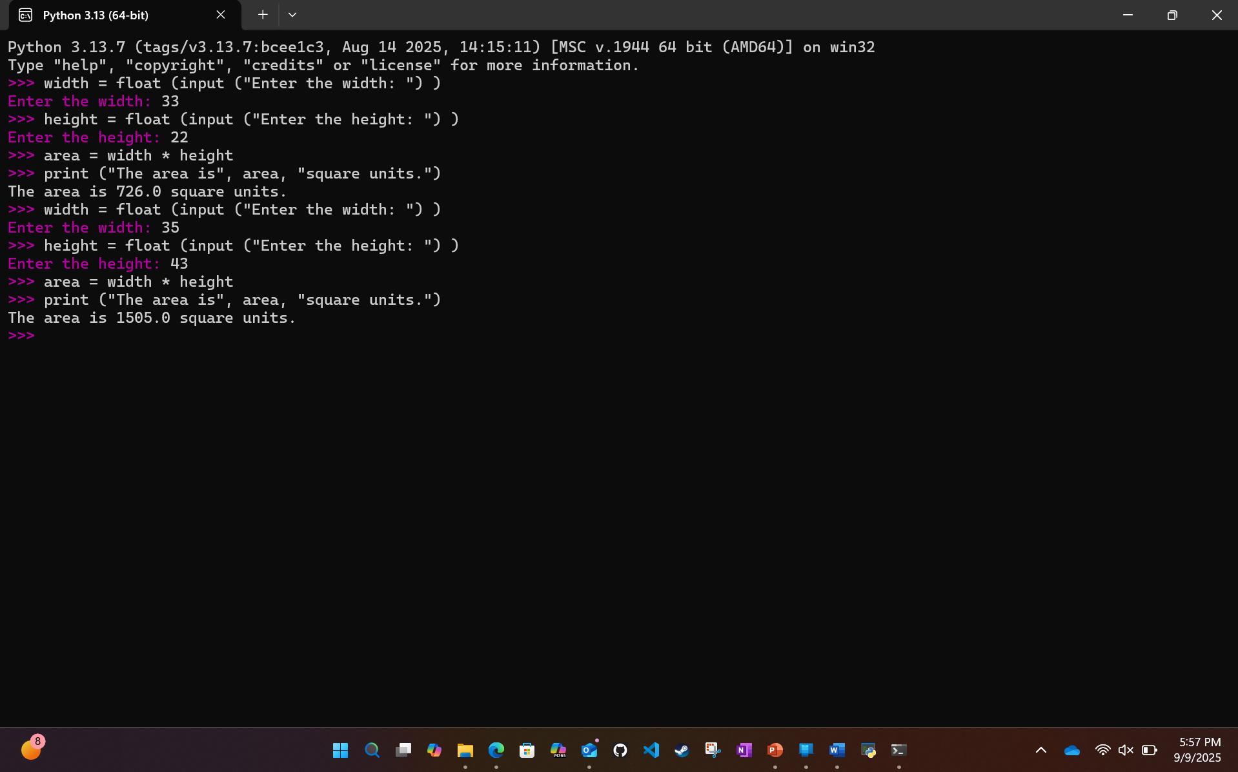

Detecting and Correcting Syntax Errors

Page 21

1. NOTE-You will get errors when doing this set of instructions, that is the point of the code, to show you some errors.
2. At the bottom of the page is your first set of code to type in, no changes to what is there.  I know that the word is spelled incorrectly, do not correct the spelling, type it in wrong.  You need to see the error that Python displays.
3. Near the bottom is a one line code example to type in.  At first glance everything looks correct so why the error?  If you had not read the paragraph following the example, it tells you that there is a space before the word print.  Be sure to put that space before the word print in that example to get the output shown in the text.
4. Screen shot the first two steps.  As they are on the same text page,  you may use a single screen shot to grab both of them.

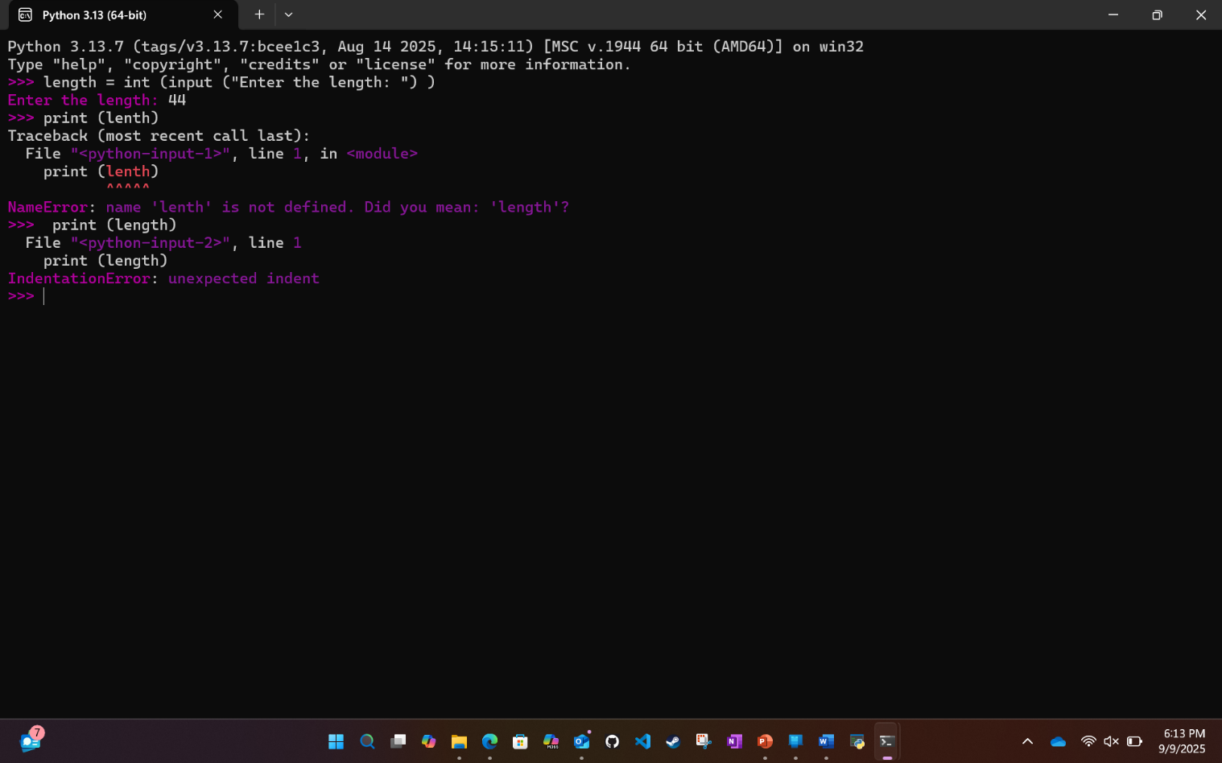

Page 22

1. There is only a single line of example code to be entered for this page.  Be sure not to correct the error as show in the text, just type it in as is to see the error displayed.
2. Since this is the last text book page of this exercise set, I will give on last reminder that all the examples on a single page can be in a single screen shot if they fit.  For future Text Book Exercise Assignments, it will be on you to remember all the examples on a single page can be in one screen shot if possible.  Separate pages though will need to be in different screen shots

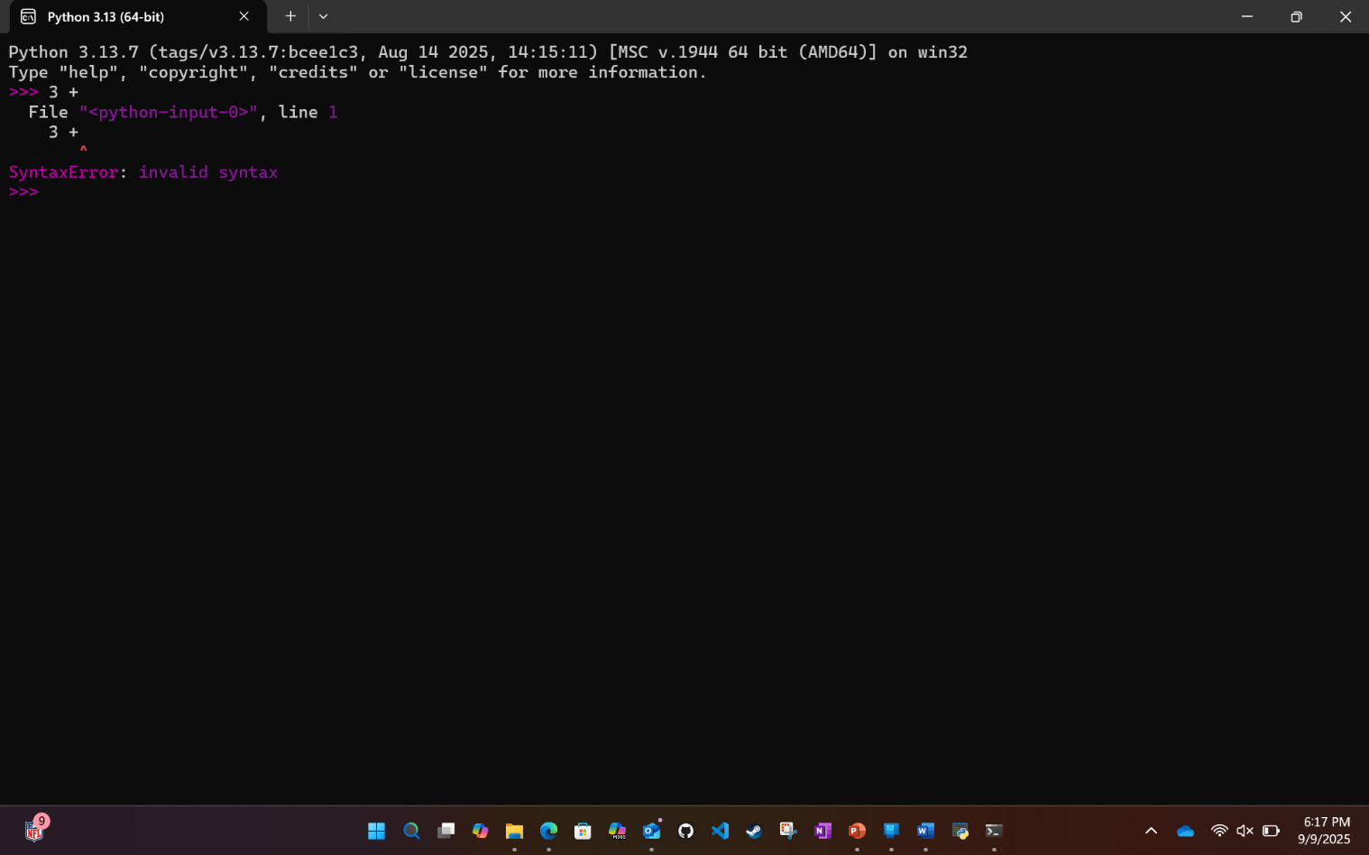

You have made it to the end of the first Text Book Exercise assignment.  The screen shots you took should be in the Submission document.  All coding was done in the interactive model for this exercise so there is no code to submit for this exercise.  Turning in just the submission document is acceptable for this assignment.  Future assignments may require that you zip files together into a zip file for submission.